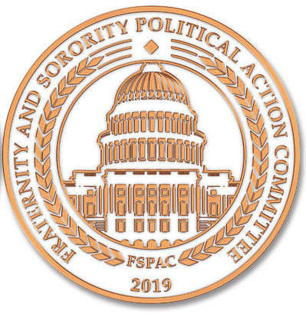

Fraternity and Sorority Political Action Committee
2026 Spring In-Person Meeting

Arnold & Porter LLP
601 Mass Ave NW, Washington D.C. 20001
April 16, 2026 7:30 AM-Noon
Breakfast Available Beginning at 7:30 AM

Meeting Objectives: Key objectives for this meeting include:
- Review Financial, legal, and organizational items for all board members
- Meet new board members and renew relationships with others
- Discuss 2025-26 Fundraising activities
  - Review Congressional Dinner
- Amend FSPAC Candidate Contribution Priorities
- Fundraising Training
- Fundraising Contacts with Lapsed Donors
- Review Communications
- Interim Report from Nominating Committee
- Update on Legislative Agenda
- Report from Fraternity & Sorority Action Fund and vote to approve or disapprove proposed potential name change
- Review logistics for fall board meeting – Potential Dates/Locations

** Referenced Documents are noted in red and match the document name

OPTIONAL - Hot Buffet Breakfast and Social Interaction (7:30-8:00)

- Welcome Review Agenda (Mike Greenberg) (8:00-8:05)
FSPAC Board Agenda April 2026
FSPAC Bylaws (Updated Fall 2023)

- Roll Call (Dorcas Washington) (8:05-8:10)

- Approval of Minutes (Dorcas Washington) (8:10-8:15)

- Financial Report (Thomas Maxwell) (8:15-8:30)
  - Potential Adjustment to Budget to Meet Fundraising
Current Financial Statements (Emailed Separately)

- Legal Review (Megan Sowards Newton) (8:30-8:45)
Legal Memo on Organizational Activities

- Dinner Recap (Kathi Heatherly) (8:45-9:00)

- FSAF Report (Sarah Lindsay) (9:00-9:20)
  - Vote on Proposed Name Change
  - Fundraising Plans
  - First Amendment Institute Report

- NomComm Interim Report (Leslie Morgan) (9:20-9:35)

- President’s Report (Mike Greenberg) (9:35-10:00)
  - Fall 2026 Board Meeting – Locations and Dates
  - Plans for May Summit

- Fundraising Update (Steve Blair) (10:00-10:15)

- Political Affairs (Laura Doerre) (10:15-10:45)
a. Review, Edits and Approval of Cycle Giving Plan
b. Discuss summer/fall fundraisers
2025-26 Short Giving Plan ( Full version released on paper at Meeting)

- Membership and Recruitment (Gayle Fitzpatrick) (10:45-11:05)
  - Recruitment of New Groups
  - Orientation and Board Development – Update Board Manual
  - Student Advisory Committee Report (Student Board Members)
- Communications Update (Alicia Lee) (11:05-11:15)
  - Website
  - Newsletter
  - Google Photo Album - https://photos.app.goo.gl/M8hmBSPXhGejqZuM7 or email to Alicia Lee
  - Email Blasts

- Legislative Update (Kevin O’Neill) (11:15-11:20)

- Fundraising Activity (Pennington & Company) (11:20-11:50)
  - Training
  - Emails and Phone Time with Lapsed Donors

- Final Comments / Adjourn (Mike Greenberg) (11:55-Noon)

