**Week of Giving Solicitation letter for your use**

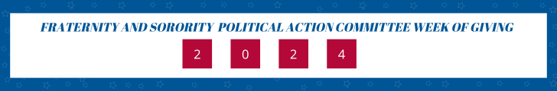

Dear xxx:  
  
The Fraternity and Sorority Political Action Committee is hosting our third annual Week of Giving campaign, from September 10 and culminating on September 17, Constitution Day.

The fall semester starts with a new slate of classes and new members joining our organization and yet we continue to see threats to the fraternity experience on our university and college campuses, including our freedom to associate as a single-sex organization, most recently as seen at the University of Maryland.

With your [donation](https://fspac-week-of-giving-2024.causevox.com/), we provide financial support to federal candidates who support, defend, and enhance that fraternal experience, ensuring our right to associate.

[Will you give $20, $200, $2,000 today? Join us in celebrating our constitutional founding.](https://fspac-week-of-giving-2024.causevox.com/)

Today, the FSPAC is the largest political action committee focused solely on higher education issues. We are truly bipartisan and contribute to individuals regardless of political party who believe in the benefits and personal growth opportunities fraternities and sororities offer collegiate men and women.

The 2024 general election is right around the corner. We have candidates who support our issues and can use our collective support.

Donate today!

Fraternally,

Xxx

*Contributions to the Fraternity and Sorority PAC are not tax-deductible for federal income tax purposes. Federal law requires the Fraternity and Sorority PAC to use its best efforts to collect and report the name, mailing address, occupation and employer for each individual whose contributions are $200 or more in a calendar year. Funds received in response to this solicitation will be subject to federal contribution limits and source prohibitions. Contributions are limited by law to $5,000 per year from any individual or PAC, and contributions from corporations, labor unions, federal contractors and foreign nationals are prohibited.*