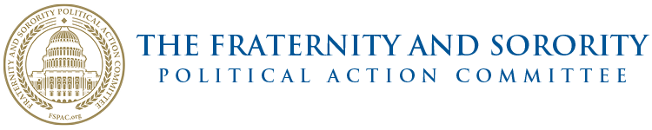
MINUTES
FSPAC Board of Directors Spring Meeting
Washington, DC
June 17, 2024

- President Mike Greenberg called the meeting to order at 8:03 P.M. Eastern.

- 33 members of the board, comprising a quorum, were in attendance

- The minutes from the April meeting were tabled until the next board meeting.

- President Mike Greenberg:
  - The Nominating Committee has been appointed and they will appoint their chairperson.
  - The 20th Gala Committee has been appointed with Anthony Albanese and Kathy Heatherly as Co-Chairs. Betty Quick will once again handle the dinner. We are hoping for 300 to 350 people and are in the process of finding a location.

- Treasurer Steve Blair: Steve reports that the FSPAC is in a good financial position. Kevin O’Neill is in the process of notifying each group about their current standings for board seats for 2025.

- Vice President Fundraising Kitty deKieffer: 85 people are on the list to attend our upcoming Dallas event and she thanked the host committee. Indianapolis and Las Vegas will be addressed next. Kitty offered kudos to those that have been fundraising and offered to help anyone who needs it.

- Vice President Membership and Orientation Donna Chereck: Donna has had a conversation with the Executive Committee on how to bring in new members. In October, we will be hosting an event for CEO’s and Panhellenic Officers in Indianapolis. Our hope is to get back to pre-Covid numbers. We will then host some type of event for the men.

- Vice President Political Affairs Carole Jones: $11,000 was given to Dems and $28,000 was given to Republicans. Various FSPAC members will represent us at political events. Carole has developed a document to provide guidance when attending these events and this has been distributed to the board.

- Vice President of Communications David Ashinoff: David’s email has been down but he is working on catching them up. If you need assistance from him, please email him at David.ashinoff@gmail.com.

- Executive Director Kevin O’Neill:
  - Kevin will be on a call with the Kappa Sigs after this board meeting to hopefully get them to participate with us again.
  - The deadline is next Friday for the student polling initiative and the pollster will join us in Las Vegas.
  - Kevin updated the board on Columbia University.
  - There are less than 35 legislation days before the election.

- Chair Alicia Lee Week of Giving: Constitution Day this year is on a Thursday which allow us more days to get donors involved and to do touches.

- Co-Chair Gayle Fitzpatrick Student Advisory Board: Caroline Kovata was in attendance at our meeting for the first time.

The meeting was adjourned at 8:40 P.M. Eastern.

